Integrating Logitech Gaming SDK with Realistic Car Controller V3.4

# Importing Packages

First, you will need to import latest **Logitech Gaming SDK** to your project. You can import it from RCC Settings (**Tools 🡪 BCG 🡪 RCC 🡪 Edit Settings**) or here;

https://assetstore.unity.com/packages/tools/integration/logitech-gaming-sdk-6630

Then you have to import “**RCC Logitech Gaming SDK Integration**” package to your Project. It can be found in **RealisticCarControllerV3** folder. If you import integration package before importing the SDK, you will have errors.

And lastly, select your current controller type as “**Logitech Steering Wheel**” in RCC Settings (**Tools 🡪 BCG 🡪 RCC 🡪 Edit Settings**). You can customize buttons there.

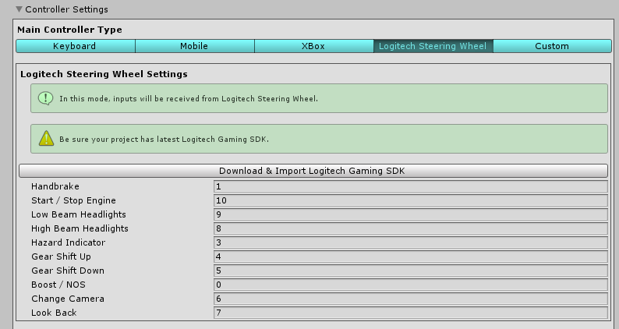

# How does it work?

_RCCSceneManager creates a new gameobject **“_RCCLogitechSteeringWheelManager**” with script attached on to it. This script reads inputs from steering wheel and feeds RCC_Input.

# What’s inside _RCCLogitechSteeringWheelManager?

It initializes connected steering wheel with SDK at start. And receiving inputs from steering wheel and pedals. Also listening to vehicle collision events for force feedback effects. You can find button press/trigger/up functions in the script. Each button has unique number and can be changed from RCC Settings.

# Notes & Advices

I’ve developed the integration with **Logitech G29/920 Steering Wheel**. Therefore, you may want to change some values in the script for different models. But it should work fine with all Logitech steering wheels. I would recommend you to use **Logitech Gaming Software**.